CS118 Homework 1

Bolun Hu

104056403

**Problem 1**

In the textbook the definition of protocol is as follows:

*A* ***protocol*** *defines the format and the order of messages exchanged between two or more communicating entities, as well as the actions taken on the transmission and/or receipt of a message.*

Therefore, a network protocol is the format and the order of messages exchanged between two end systems in a network.

**Problem 2**

1. True
2. False
3. False

**Problem 3**

(a) A circuit-switched network would be well suited to the application, because the application involves long sessions with predictable smooth bandwidth requirements. Since the transmission rate is known and not bursty, bandwidth can be reserved for each application session without significant waste. In addition, the overhead costs of setting up and tearing down

(b) In the worst case, all the applications simultaneously transmit over one or more network links. However, since each link has sufficient bandwidth to handle the sum of all of the applications' data rates, no congestion (very little queuing) will occur. Given such generous link capacities, the network does not need congestion control mechanisms.

**Problem 4**

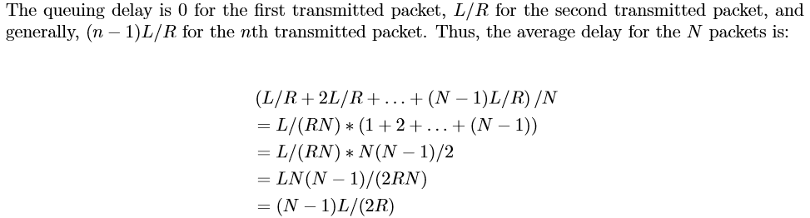

**Problem 5**

